2020 Leaving Cert Physics Paper (Higher Level)

2020 Question 1
In an experiment to verify the principle of conservation of momentum, body A was set in motion
with a constant velocity. It was then allowed to collide with a second body B, which was initially at
rest and the bodies moved off together at constant velocity.
The following data were recorded.

Mass of body A = 125.6 g
Mass of body B = 111.1 g
Distance travelled by body A for 0.2 s before collision = 11.4 cm
Distance travelled by bodies A and B for 0.2 s after collision = 6.1 cm
- Draw a labelled diagram of how the apparatus was arranged in this experiment.
- Describe how the time interval was measured.
- How were the effects of (a) friction and (b) gravity minimised?
- Use the data to calculate the initial and final velocities of body A.
- Use the data to demonstrate how the experiment verifies the principle of conservation of momentum.

2020 Question 2
In an experiment to determine the refractive index of glass, light was passed through a glass block and the angles of incidence i and refraction r were measured for different values of i.
The following data were recorded.
i (⁰) | 30 | 40 | 50 | 60 | 70 | 80
r (⁰) | 19 | 25 | 31 | 35 | 39 | 41

- Explain how the refracted ray and the angle of refraction were determined.
(A labelled diagram may help your answer.)
- Why would using a smaller angle of incidence have led to a less accurate measurement of the angle of refraction?
- Use the data to draw a suitable graph to verify Snell’s law.
- Explain how your graph verifies Snell’s law.
- Use your graph to calculate the refractive index of the glass.

2020 Question 3
In an experiment to determine the speed of sound in air a student determined the lengths l of a narrow column of air when it was vibrating at different fundamental frequencies f.
The following data were recorded.

f (Hz) | 250 | 300 | 350 | 400 | 450 | 500
l (cm) | 34.0 | 28.3 | 24.0 | 20.5 | 19.1 | 17.0

- Draw a labelled diagram of how the apparatus was arranged in this experiment.
- How did the student determine the length of the air column for a particular frequency?
- How did the student ensure that the fundamental frequency, not an overtone, was observed?
- Use the data to draw a graph of f against ¹/l.
- Calculate the slope of your graph.
- Hence or otherwise calculate the speed of sound in air.

2020 Question 4
In an experiment to determine the resistivity of nichrome, the resistance R of a length l of wire of uniform diameter was recorded. This was repeated for a number of different lengths of the wire.
The diameter of the wire was also measured.
The following data were recorded.

l (cm) | 30 | 40 | 50 | 60 | 70 | 80
R (Ω) | 0.11 | 0.14 | 0.17 | 0.21 | 0.24 | 0.28

Diameter of wire = 2.05 mm

- Name the pieces of apparatus that were used to measure (a) the diameter, (b) the length and (c) the resistance of the wire.
- How did the student ensure that the diameter of the wire was uniform?
- Use the data to draw a graph of R against l.
- Calculate the slope of your graph.
- Hence calculate the resistivity of the metal.
- How would the resistance of a fixed length of wire change if its diameter was doubled?

2020 Question 5


- State Boyle’s law.
- A neutron star has a density of 3.7 × 10¹⁷ kg m^{–3}.
What would the radius of the Earth be if it had the same density as the neutron star?
(mass of Earth = 6.0 × 10²⁴ kg)
- A spring has a length of 22 cm when a 2 N weight hangs from it. The spring constant is 50 N m^{–1}.
Calculate the natural length of the spring.
- Draw a ray diagram to show the formation of an image in a convex mirror.
- What is meant by the amplitude of a wave?
- Name one of the three primary colours of light. What is its complementary colour?
- Draw a labelled diagram to show how an electric field pattern can be demonstrated in the laboratory.
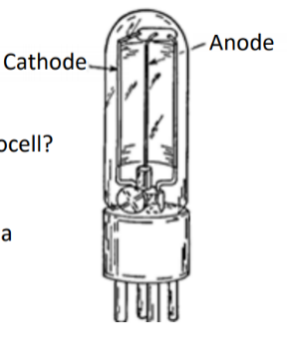
- Distinguish between intrinsic and extrinsic conduction in a semiconductor.
- The diagram shows a sketch of a photocell.
    - What particles move between the electrodes of the photocell?
    - In what direction do the particles move?

- Write a nuclear equation to show the pair annihilation of a positron and an electron.
Or
Draw the truth table for an OR gate.

2020 Question 6

Motion and the effects of forces can be explained using Newton’s three laws of motion.
- State Newton’s laws of motion.
- Show that F = ma is a special case of Newton’s second law.

- Describe an experiment to find the resultant of two co‐planar vectors. A cricket player moves her hands away from the motion of the ball as she catches it.
- Use Newton’s laws of motion to explain why she moves her hands away from the motion of the ball.

She then throws a ball upwards with an initial velocity of 28 m s^{–1} at 45° to the horizontal. Her hand was 1.6 m above the ground. A short time later the ball was caught by another player. When it was caught the ball was again at a height of 1.6 m.
Calculate
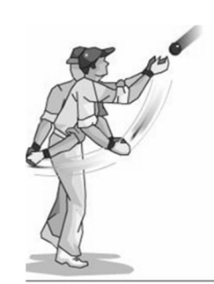
- how long the ball was in the air
- the horizontal distance travelled by the ball
- the maximum height above the ground reached by the ball.
- Draw a diagram to show the velocity v and acceleration a of the ball when it is at its maximum height.
Also show the force(s) F on the ball. Use the letters v, a and F to label your vectors.
(acceleration due to gravity = 9.8 m s^{–2})

2020 Question 7

All insulated metal bodies can store charge.
- Describe how a pear‐shaped metal body can be charged by induction.
- Draw a diagram to show the distribution of charge on the body after charging.

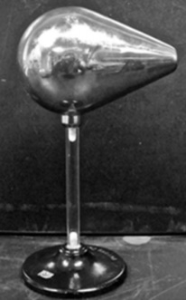
A charged capacitor stores energy.
- Define capacitance.
- Draw the circuit symbol for a capacitor.
- A 4000 µF capacitor is connected across 500 V.
The stored energy is converted to heat when the capacitor is discharged through a heating element placed in 40 g of water in an insulated container.
Calculate the maximum rise in temperature of the water.
- Describe an experiment to demonstrate how the capacitance of a parallel‐plate capacitor changes with the distance between the plates.

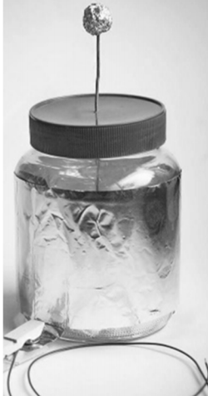
A Leyden jar acts as a parallel‐plate capacitor.
A student makes a Leyden jar in the laboratory. It consists of a cylindrical glass container of internal radius 6 cm. The glass in the jar is the capacitor’s dielectric and has a relative permittivity of 2.1 and a thickness of 5 mm.
Aluminium foil of height 17 cm coats the inside and outside vertical walls of the jar.
- Calculate the surface area of the inner cylinder of aluminium foil.
- Calculate the capacitance of the Leyden jar.
- What property of glass allows it to be used as a dielectric?
(specific heat capacity of water = 4180 J kg^{–1} K^{–1})

2020 Question 8
Radioactivity was discovered in 1896 by Henri Becquerel.
- Define radioactivity
- Define the becquerel.

In the uranium decay series, U–238 decays to Pb206 in a series of alpha and beta decays.
The first decay in this series is an alpha decay and the final decay is a beta decay.

- Write a nuclear equation for the first decay in this series.
- Write a nuclear equation for the final decay in this series.
- Calculate the total number of alpha particles and the total number of beta particles emitted in the series

The half‐life of U–238 is 4.5 × 10⁹ years.
- How long will it take for the number of U-238 nuclei in a sample to decrease by a factor of 8?
- A sample of U–238 contains 3.2 × 10¹⁰ nuclei. Calculate its activity.
- U-38 is an isotope of uranium. What are isotopes?

- Radon gas forms part of the uranium decay series.
- Why is radon considered to be dangerous?
- How can the build-up of radon in a building be reduced?

2020 Question 9

There are two types of guitars, acoustic guitars and electric guitars.
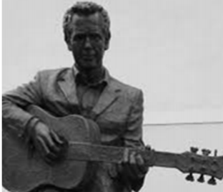
In acoustic guitars resonance occurs between the vibrating strings and other parts of the guitar.
- Define resonance.
- Describe a laboratory experiment to demonstrate resonance.
- A guitar string has length 2 m and mass 0.88 g. It is stretched across two fixed points which are 65.1 cm apart on a guitar. It is then plucked and it vibrates at a fundamental frequency of 330 Hz.
Draw a labelled diagram to show a guitar string vibrating at its fundamental frequency.
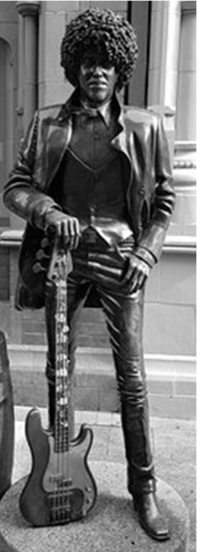
- Calculate the tension in the string
- Calculate the speed of sound in the string.
In an electric guitar a magnetic pickup detects the vibration in the string. The pickup consists of a stationary magnet and a coil around the magnet. When the string vibrates an emf is induced.

- Draw the magnetic field around a bar magnet.
- Explain how an emf is induced in the coil.
- Sketch a graph to show how the output current varies with time.

Question 10 – answer part (a) or part (b)

2020 Question 10 (a)
Fermilab is an American particle physics laboratory, named after the Italian physicist Enrico Fermi.
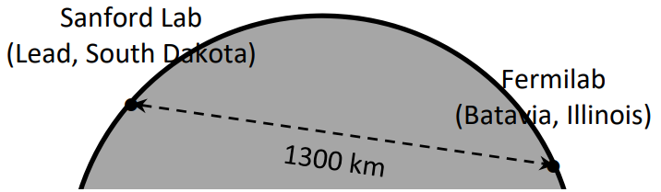
Work on the Deep Underground Neutrino Experiment (DUNE) commenced in Fermilab in 2017, with a planned completion date of 2026. Protons will be accelerated to hit a fixed target.
They will produce pions and kaons, which will then decay and transform into an intense beam of neutrinos.
The neutrinos will travel at 0.99c through the Earth, no tunnel required, to a neutrino detector in South Dakota.

- What are the two fundamental forces that the neutrino experiences?
- Pions and kaons are members of the meson family. What are mesons?
- List the three types of neutrino in order of increasing mass.
- Why is no tunnel required to transport the neutrinos underground to South Dakota?
- Calculate the time taken for the neutrino to travel from Fermilab to South Dakota.

In another experiment in Fermilab two protons, each with a kinetic energy of 29 GeV, collide and new particles are created.
After the collision, the total kinetic energy of the two protons and the new particles is 16 GeV.
- Calculate the total mass of the new particles created.
- Enrico Fermi proposed the existence of the neutrino. He also built the first self‐sustaining nuclear fission reactor.
What is nuclear fission?
- Why was Fermi’s nuclear reactor self‐sustaining?
- Graphite was used in his nuclear reactor. What was the purpose of the graphite?
- Is nuclear fission a spontaneous or a non‐spontaneous process? Explain your answer.

2020 Question 10 (b)
- A moving‐coil galvanometer detects and measures small currents.
Describe, with the aid of a labelled diagram, the principle of operation of the galvanometer.
- Draw labelled diagrams to show how a moving‐coil galvanometer can be converted into (a) an ammeter, (b) an ohmmeter.
- A moving‐coil galvanometer has a full scale deflection of 50 mA and an internal resistance of 7.2 Ω. Calculate the resistance required to convert it into a voltmeter with full scale deflection of 10 V.
- LEDs can also indicate the flow of current.
What is an LED?
- Describe, with the aid of a labelled diagram, the principle of operation of an LED.
- LEDs are fragile. How can they be protected in a circuit?
- State two differences between LEDs and photodiodes

2020 Question 11

Read the following passage and answer the accompanying questions.
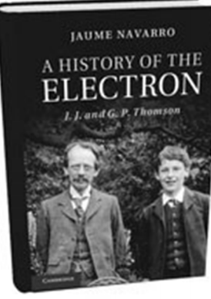
A History of the Electron
In 1897, J.J. Thomson ascribed particle nature to the carriers of electricity in cathode rays. This is traditionally known as the date of the discovery of the electron. Exactly thirty years later, his sonG.P. Thomson observed the first ever images of electron diffraction, with which he showed the wave‐like behavior of his father’s electrons.
Ironically, while his father had showed that a wave phenomenon (cathode rays) could be explained in terms of particles (electrons), the son was reclaiming wave characteristics for his father’s particles.
Soon after J.J. Thomson had found evidence of the atomicity of electric charges, physics began to move towards a more fundamental atomicity, that of energy. The age of quantum physics had begun.
In 1904, J.J. Thomson proposed the ‘plum pudding model’ of the atom. He considered the atom to ‘consist of a number of negatively charged corpuscles enclosed in a sphere of uniform positive charge’. In 1909, Geiger and Marsden conducted experiments with thin sheets of gold. Their professor, Ernest Rutherford, interpreted their results and improved Thomson’s model with his nuclear model of the atom. Later Niels Bohr, working with Rutherford in Manchester, expanded the nuclear model, proposing what is now known as the Bohr model. He had previously worked with J.J. Thomson in Cambridge.

Adapted from ‘A History of the Electron’, J.J. and G.P. Thomson (Jaume Navarro) Cambridge University Press 2019

  - J.J. Thomson used cathode ray tubes in his research. How are electrons (i) produced, (ii) deviated in a cathode ray tube?
  - Cathode rays are accelerated through a potential difference of 4 kV in a cathode ray tube.
Calculate the maximum speed of an electron in the tube.
  - What pieces of apparatus can be used to demonstrate the diffraction of light in the laboratory?
  - Geiger also played an important role in the development of the Geiger counter, a detector of nuclear radiation. Describe the principle of operation of any detector of nuclear radiation.
  - Describe the Geiger‐Marsden experiment that used thin sheets of gold. Include their setup, observations and conclusions.
  - Describe with the aid of a labelled diagram the Bohr model of the atom. Use the model to explain emission line spectra.

2020 Question 12
Answer any two of the following parts, (a), (b), (c), (d).

(a)
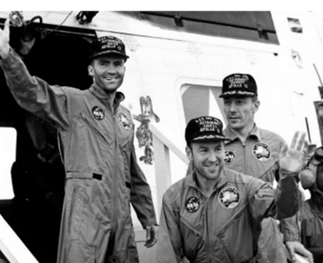
Fifty years ago the Apollo 13 mission to the Moon captured the public’s imagination when technical issues led to the aborting of the planned Moon landing. The three astronauts on the mission travelled further from the Earth than anyone before or since.

- Derive an expression for the period of orbit T of the Moon when it has a radius of orbit R around the Earth (of mass M).
- Calculate the period of the Moon as it orbits the Earth.
- Calculate the gravitational force exerted by the Moon on an astronaut of mass 80 kg when he is 250 km above the surface of the Moon.
- Astronauts appear to be weightless when they orbit the Moon. Explain why.

mass of Earth = 6.0 × 10²⁴ kg
mass of the Moon = 7.3 × 10²² kg
radius of the Moon = 1740 km
radius of the Moon’s orbit around Earth = 3.85 × 10⁸ m

(b)
On a particular day, solar radiation falls on the surface of Antarctica at a rate of 850 W m^{–2}. 52% of the incoming radiation is infra‐red radiation. The average frequency of the infra‐red radiation is 15 THz.
- Radiation is one of three methods of heat transfer. What are the other two methods?
- Calculate the infra‐red energy that falls on 0.25 m² of Antarctica in 3 minutes.
- Calculate the number of infra‐red photons that fall on this area in this time.

- As part of the greenhouse effect infra‐red radiation is reflected back to Earth. This leads to global warming. As the Earth warms its glaciers continue to melt. At present the total volume of ice in glaciers on Earth is 170,000 km³.
- Calculate the energy required to melt 0.5% of the Earth’s glaciers if their average temperature is –6 °C and the melting point of glacier ice is –2 °C.

density of glacier ice = 920 kg m^{–3};
specific latent heat of fusion of glacier ice = 3.3 × 10⁵ J kg^{–1}
specific heat capacity of glacier ice = 2900 J kg^{–1} K^{–1}
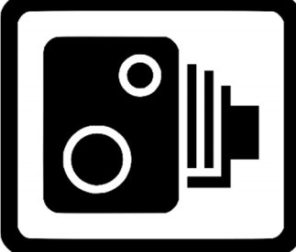

(c)
Speed cameras make use of the Doppler effect.
- What is the Doppler effect?
- Explain, with the aid of labelled diagrams, how the Doppler effect occurs.

- A source of sound approaches a stationary observer.
The source appears to have a frequency that is 20% greater than its frequency at rest.
Calculate the speed of the source.
- The Doppler effect is also used to detect the red‐shift of galaxies.

- What does the red‐shift tell us about the universe?
(speed of sound in air = 340 m s^{–1})

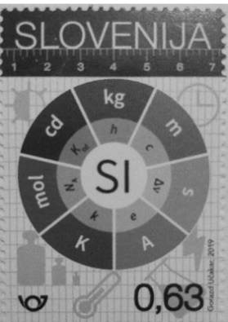
(d)
In May of 2019 the definition of the ampere, the SI unit of current, was changed. It is now defined in terms of the value of e, the elementary charge.
- What is current?
- Calculate the current flowing when a mole (6.0 × 10²³) of electrons passes a point in 30 minutes.

The previous definition of the ampere was based on the phenomenon of two parallel current‐carrying conductors exerting a force on each other.
- Explain why this phenomenon occurs.
- Describe a laboratory experiment to demonstrate this phenomenon.

